Nagios Plugin
V100R001C00
 | User Guide
 | Issue | 02
 | Date | 2018-02-07

About This Document
Purpose
This document describes how to install, configure, monitor, and uninstall the Nagios plugin.
Intended Audience
This document is intended for:
- Technical support engineers
- Maintenance engineers
Symbol Conventions
The symbols that may be found in this document are defined as follows.
Symbol | Description
 | Indicates an imminently hazardous situation which, if not avoided, will result in death or serious injury.
 | Indicates a potentially hazardous situation which, if not avoided, could result in death or serious injury.
 | Indicates a potentially hazardous situation which, if not avoided, may result in minor or moderate injury.
 | Indicates a potentially hazardous situation which, if not avoided, could result in equipment damage, data loss, performance deterioration, or unanticipated results.  NOTICE is used to address practices not related to personal injury.
Calls attention to important information, best practices and tips.
NOTE is used to address information not related to personal injury, equipment damage, and environment deterioration.

Change History
Changes between document issues are cumulative. The latest document issue contains all the changes made in earlier issues.
Issue 02 (2018-02-07)
Modified 2.3.2 Adding or Deleting Servers.
Issue 01 (2017-04-30)
First official release.
Contents
About This Document ii
1 Overview 1
2 Installing the Plugin 2
2.1 Installation Process 2
2.2 Preparing for Installation 2
2.3 Installing the Plugin and Adding Servers Manually 4
2.3.1 Installing the Plugin 4
2.3.2 Adding or Deleting Servers 5
3 Obtaining Information 10
4 Monitoring Servers 12
5 FAQs 14
5.1 How Do I Uninstall the Plugin? 14
5.2 How Do I Restart the Plugin Service? 15
5.3 What Should I Do If Host Service Status Cannot Be Displayed on the Nagios Home Page? 16
5.4 What Should I Do If SNMPv3 Alarms Cannot Be Reported? 17

Overview
This chapter describes the basic functions of the Nagios plugin.
Function
After the Nagios tool is installed with the Nagios plugin, it can manage Huawei servers and monitor the status of components such as power supply units (PSUs), fans, and RAID controller cards.
Supported Servers
- For details about Huawei servers that can be monitored by Nagios, see the Nagios Plugin V100R001C00SPC200 Version Mapping.
- Nagios supports a maximum of 1,000 servers.
- Nagios can run on SLES 10.2 and Ubuntu 14.04.
- For V3 servers, the Nagios plugin supports alarms in the event code format.
- Nagios Plugin supports only commas (,) as alarm delimiters. You need to change the delimiter to comma in the trap IP address registration area on the device WebUI.

Installing the Plugin

Installation Process
Figure 1-1 shows the process of installing the Nagios plugin.
              - Installation process
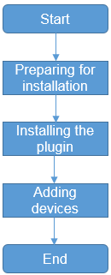

Preparing for Installation
This section describes the preparations for installing the plugin.
Software Requirements
Before installing the plugin, ensure that the system meets the following requirements:
- The Python tool version is Python 2.7.13.
- The Nagios tool version is Nagios Core-3.5.1 or Nagios Core-4.3.4.
- The following files exist on the Nagios server:
- pysnmp-4.2.4.tar.gz
- pyasn1-0.1.6.tar.gz
- pycrypto-2.3.tar.gz
Download the pysnmp-4.2.4.tar.gz, pyasn1-0.1.6.tar.gz, and pycrypto-2.3.tar.gz files and upload them to any directory on the Nagios server, for example, /usr/local) and install the software. The procedure for software installation is as follows:
            - Run the following command to decompress the software package.
tar xzvf $sourcName
For example, If pysnmp-4.2.4.tar.gz is used as an example, run tar xzvf pysnmp-4.2.4.tar.gz.
            - Run the following command to go to the decompression directory.
cd
For example, if pysnmp-4.2.4.tar.gz is used as an example, run cd pysnmp-4.2.4.
            - Run the following commadn to install the software:
python setup.py install
If the system has multiple python versions, run the export PATH=$pythonPath:$PATH command, where $pythonPath indicates the directory where Python 2.7.13 is located.
- The plugin installation package Huawei eSight Server Management Plugin (for Nagios).gz has been obtained.
Download the Tecal Nagios Plugin V100R001C00SPC202 installation package from http://support.huawei.com/enterprise.
Data Preparation
Table 1-1 lists the data required for installing the plugin.
                - Table1 Required data
Item | Function | Example
IP address of the Nagios server | Used to access the server where the Nagios tool is installed and install the plugin. | 192.168.1.110
Path for uploading the installation package to the Nagios server | Used to install the plugin installation package on the Nagios server. | /etc  NOTE  The software is decompressed in the /etc/Huawei eSight Server Management Plugin (for Nagios) directory.
Software installation path | Used to install the plugin on the Nagios server. | /usr/local/nagios
User name for logging in to the Nagios server | Used to log in to the OS of the Nagios server. | root
Password of the Nagios server user | Used to log in to the OS operating system of the Nagios server. | huawei123
Basic information about managed servers | You can configure information about managed servers on the Nagios server so that the Nagios server can monitor the servers. The following information is required:  - IP address of the managed server  - Host name of the managed server  - User name for logging in to the managed server  - Password for logging in to the managed server  - SNMP read/write community name for communicating with the Nagios server  - SNMP version. By default, only the SNMP V3 is enabled on the server side. If you need to use SNMP V1 or SNMP V2C to add a server, log in to the server to enable the SNMP V1 or SNMP V2C protocol and obtain the read and write community names of the protocol. For details, see the manuals released with the server.  - Trap community name, which is used when the server reports an alarm.  NOTE  If SNMP V1 or SNMP V2C is used, the system reports only alarms related to SNMP V1 or SNMP V2C, but not alarms related to SNMP V3. | - 192.168.1.100  - huawei-1  - root  - huawei123  - public  - v3  - Huawei12#$

Tools
PuTTY software

Installing the Plugin and Adding Servers Manually
This section describes how to install the plugin and add servers.

Installing the Plugin
This section describes how to install the plugin. The plugin for this version is not compatible with the configuration file of V100R001C00SPC201 or earlier. In the case of plugin installation during system upgrade, do not save the configuration file.
Prerequisites
- The installation package has been uploaded to the Nagios server.
- You have logged in to the Nagios server as the root user.
Operation Procedure
            - Run the following commands to decompress the installation package:
cd /etc
tar -zxf Huawei eSight Server Management Plugin (for Nagios).gz
The Huawei eSight Server Management Plugin (for Nagios) folder is generated.
            - Run the following commands to install the plugin and add server information to the Nagios system:
cd Huawei eSight Server Management Plugin (for Nagios)
python setup.py install -d 10.10.10.10 -p 10061 -n /usr/local/nagios
The parameters are described as follows:
- The parameter following -d indicates the IP address of the Nagios server.
- The parameter following -n is the installation path of the Nagios tool.
In the preceding command, /usr/local/nagios indicates the installation path. Change it based on the site requirements.
- The parameter after -p indicates the Nagios alarm listening port. This parameter is optional. The default port number is 10061.
If multiple Python versions exist in the system, the error message "check python version fail, please check you python is 2.7.13" may be displayed during the installation. If the path of the Python 2.7.13 application is /usr/local/bin, run /usr/local/bin/python setup.py install -d 192.168.1.110 -p 10,061 -n /usr/local/nagios to install the Nagios plugin.
----End

Adding or Deleting Servers
After the plugin is installed, you can add Huawei servers to be monitored on the Nagios server.
Prerequisites
- The plugin has been installed. For details, see 2.3.1 Installing the Plugin.
- You have obtained information about managed servers.
If the E9000 is to be added, ensure that the static IP address of the HMM is cleared.
- The managed servers have registered a Trap IP address.
- You have logged in to the Nagios server as the root user.
Adding Servers Using config.py Commands
Table 1-1 describes the config.py commands.
                - config.py command description
Command | Description
add | Add a single server.
batch | Adding servers in batches.
del | Delete a server. The server can be deleted in batches or one by one.
inquiry | Query the configured server.
version | Query the current version number.
resetserver | Clear the trap IP address of the interconnected server.

Adding a Single Server
            - Switch to the directory where config.py is located.
cd /usr/local/nagios/bin/huawei_server
            - Run the following command to add a server:
python config.py add -i 10.10.10.10 -t Rack -p 161 -a ****** -v v3 -u root -x SHA -d AES -A ****** -V v3 -U root -X SHA -D AES
                - Command parameters
Parameter | Description
-i | IP address of the monitored server.
-H | Name of the monitored server. This parameter is optional. If this parameter is left blank, the value is the same as the IP address. This parameter is not recommended and cannot be specified during batch configuration.
-t | Type of the monitored server. The options are as follows:  - Rack  - Blade  - HighDensity
-p | SNMP service port of the monitored server. If this parameter is left blank, default value 161 is used.
-v | SNMP protocol version used to query and monitor the monitored server. The value can be v1, v2, or v3 (v3 is recommended). If this parameter is left blank, default value v3 is used.
-V | SNMP version used for receiving trap messages from the monitored server. The value can be v1, v2, or v3 (v3 is recommended). If this parameter is left blank, default value v3 is used.
-u | User name used by the SNMP V3 protocol to query and set the monitored server. If this parameter is not specified, the trap destination IP address of the server cannot be set.
-U | User name used by the SNMP V3 protocol to receive traps from the monitored server. If this parameter is left blank, the value is the same as the value of -u by default.
-a | Password used by the SNMP V3 protocol to query and set the monitored server. If this parameter is not specified, the trap destination IP address of the server cannot be set.
-A | Password used by the SNMP V3 protocol to receive traps from the monitored server. If this parameter is left blank, the value is the same as the value of -a by default.
-x | authprotocol used by the SNMP V3 protocol to query and set the monitored server. The value can be MD5 or SHA.
-X | authprotocol used by the SNMP V3 protocol to receive traps from the monitored server. The value can be MD5 or SHA. If this parameter is not set, the value is the same as the value of -x by default.
-d | privprotocol used by the SNMP V3 protocol to query and set the monitored server. The value can be AES or DES.
-D | privprotocol used by the SNMPv3 protocol to receive traps from the monitored server. The value can be AES or DES. If this parameter is not set, the value is the same as the value of -d by default.
-c | Community name used by the SNMP V1 or SNMP V2C protocol to query and set the monitored server. This parameter is applicable only to the SNMP V1 and SNMP V2C protocols.
-C | Community name used by the SNMP V1 or SNMP V2C protocol to receive traps from the monitored server. This parameter is applicable only to the SNMP V1 and SNMP V2C protocols.

After a server is added, the plugin configures the trap parameters for the server automatically. For details about the configuration items, see Table 1-2.
                - Parameter setting
Item | Description
Trap mode | Set the trap mode to event mode.
SNMP version for sending traps | Configure the SNMP version based on the -V parameter in Table 1-1.
Destination IP address for sending traps | Set the IP address of the last trap. The iBMC uses the fourth address; the HMM uses the fifth address.
Destination port for sending traps | Set the port corresponding to the IP address of the last trap. The iBMC uses the port mapping to the fourth IP address; the HMM uses the port mapping to the fifth IP address.
Enable trap sending | Enable the trap sending function.

----End
Adding Servers in Batches
            - Switch to the directory where config.py is located.
cd /usr/local/nagios/bin/huawei_server
            - Run the following command to add a server:
python config.py batch -i 10.10.10.116-3 -t Rack -p 161 -a ****** -v v3 -u root -x SHA -d AES -A ****** -V v3 -U root -X SHA -D AES or python config.py batch -i 10.10.10.* -t Rack -p 161 -a ****** -v v3 -u root -x SHA -d AES -A ****** -V v3 -U root -X SHA -D AES
-i 10.10.10.116-119 indicates that the IP addresses of the servers to be added are 10.10.10.116, 10.10.10.117, 10.10.10.118, and 10.10.10.119 (four servers in total).
-i 10.10.10.2.* indicates that the network segment for adding servers in batches is 10.10.10..
For details about other parameters, see Table 1-1. After servers are added, the plugin configures the trap parameters for the servers automatically. For details about the configuration items, see Table 1-2.
----End
Deleting a Server
            - Switch to the directory where config.py is located.
cd /usr/local/nagios/bin/huawei_server
            - Run the following commands to delete a server or multiple servers:
- Delete a single server:
python config.py del -i 10.10.10.1
- Delete servers in batches:
python config.py del -i 10.10.10.116-119 or python config.py del -i 10.10.10.*
After a server is deleted, the destination address of the last trap is set to null for the server. (The iBMC is located in the fourth address, anduses theed in the fifth address.)
----End
Manually Clearing the Trap IP Addresses of Servers
            - Switch to the directory where config.py is located.
cd /usr/local/nagios/bin/huawei_server
            - Run the following commands to clear the trap IP addresses of servers:
- Clear the trap IP address of a server:
python config.py resetserver -i 10.10.10.1 -p 161 -a ****** -v v3 -u root -x SHA
- Clear the trap IP addresses of servers in batches:
python config.py resetserver -i 10.10.10.116-119 -p 161 -a ****** -v v3 -u root -x SHA or python config.py resetserver -i 10.10.10.* -p 161 -a ****** -v v3 -u root -x SHA
Manually set the destination address of the last trap to null for the server. (The iBMC uses the fourth address; the HMM uses the fifth address.)
----End
Querying Server IP Addresses
            - Switch to the directory where config.py is located.
cd /usr/local/nagios/bin/huawei_server
            - Run the following commands to query the server IP addresses:
python config.py inquiry
----End
Querying the Plugin Version
            - Switch to the directory where config.py is located.
cd /usr/local/nagios/bin/huawei_server
            - Run the following commands to query the plugin version:
python config.py version
----End

Obtaining Information
This chapter describes how to obtain information about rack serversuses theand high-density servers using Nagios.
Prerequisites
- The Nagios plugin has been installed and servers have been added. For details, see 2.3.1 Installing the Plugin and 2.3.2 Adding or Deleting Servers.
- You have logged in to the Nagios server as the root user.
Background Information
The Nagios enables you to obtain server information in manual or automatic mode:
- Manual mode: Log in to the Nagios server to manually run scripts to obtain information about the system, PSU, fan, CPU, DIMM, disk, PCIe card, RAID controller card, logical disk, component, sensor, and firmware version.
- Automatic mode: Configure Nagios to automatically invoke scripts to obtain information about the system, PSU, fan, CPU, DIMM, and disk.
Operation Procedure
- Manual mode:
  - Run the following command to switch to the nagios user:
su - nagios
  - Run the following command to go to the /usr/local/nagios/bin/huawei_server directory:
cd /usr/local/nagios/bin/huawei_server
  - Run the following commands to obtain the server information:
python collect.py -a -r resultPath
python collect.py –f directory /host.xml -r resultPath
                - Command description
Command | Description
python collect.py -a | Invoke the huawei_hosts.xml file to obtain server information. The result file is stored in /usr/local/nagios/bin/result by default.
python collect.py -a -r resultPath | Invoke the huawei_hosts.xml file to obtain server information. The result file is stored in a specified directory.
python collect.py –f directory /host.xml | Invoke the host.xml file to obtain server information. The result file is stored in /usr/local/nagios/bin/result by default.  NOTE  host.xml is the configuration file created by the user. The format of the file must be the same as that of huawei_hosts.xml, and the path of the file must be provided.
python collect.py -f host.xml -r resultPath | Invoke the host.xml file to obtain server information. The result file is stored in a specified directory.  NOTE  host.xml is the configuration file created by the user. The format of the file must be the same as that of huawei_hosts.xml, and the path of the file must be provided.

- Automatic mode:
The Nagios automatically invokes the script to obtain server information upon startup. The default polling interval is 5 minutes.

Monitoring Servers
This chapter describes how to monitor rack servers, high-density servers, and blade servers using Nagios.
Prerequisites
- The Nagios plugin has been installed and servers have been added. For details, see 2.3.1 Installing the Plugin and 2.3.2 Adding or Deleting Servers.
- You have logged in to the Nagios server as the root user.
Operation Procedure
            - In the navigation tree on the left, choose Current Status > Services.
            - In the Service Status Details For All Hosts area in the right pane, view the information about all monitored servers and their component status, as shown in Figure 1-1.
              - Viewing server information
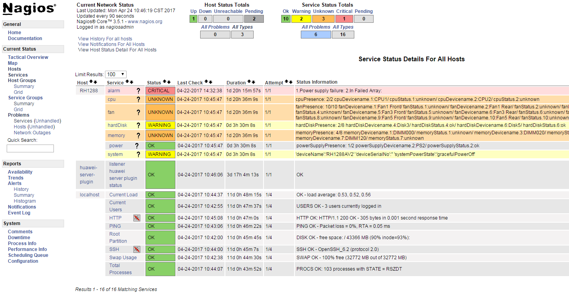

- Host: host name of the monitored server. You can click a host name to view details about the server.
- huawei-server-plugin: name of the plugin service monitored by Nagios.
- Service: component of the monitored server. You can click a component to view its status.
- Status: status of the monitored component.
----End

FAQs

How Do I Uninstall the Plugin?
This section describes how to uninstall the plugin.
Prerequisites
- The Nagios plugin has been installed.
- You have logged in to the Nagios server as the root user.
Operation Procedure
            - Run the following command to access the directory where the Nagios plugin is installed:
cd /etc
cd Huawei eSight Server Management Plugin (for Nagios)
            - Run the following command to uninstall the plugin:
python setup.py uninstall
            - When the following information is displayed, determine whether to retain user data as required:
Do you want to retain user data?(Y/N)
- To retain user data, type y and press Enter.
- If you do not need to retain user data, type n and press Enter.
The system starts to uninstall the plugin. After the uninstallation is complete, the following information is displayed:
setup.py=> [info] uninstall success.
Done.
            - Check whether the nagios.cfg file is correct.
- Run the following command to switch to the nagios user:
su - nagios
- Run the following command to check the nagios.cfg file:
/usr/local/nagios/bin/nagios -v /usr/local/nagios/etc/nagios.cfg
In the preceding command, /usr/local/nagios indicates the installation path. Change it based on the site requirements.
If the following information is displayed, it indicates that the nagios.cfg file is correct:
Things look okay - No serious problems were detected during the pre-flight check
- Run the following command to switch to the root user:
exit
            - Run the following command to restart the Nagios service:
service nagios restart
If the following information is displayed, the Nagios service is restarted successfully:
Stopping nagios: done.
Starting nagios: done.
----End

How Do I Restart the Plugin Service?
This section describes how to restart the plugin service on the Nagios server.
Prerequisites
- The Nagios plugin has been installed.
- You have logged in to the Nagios server as the root user.
Operation Procedure
            - Run the following command to check whether the plugin alarm service has been started:
ps -ef |grep trapd.py |grep -v grep
If the following information is displayed, it indicates that the plugin alarm service has been started: Otherwise, wait for 2 minutes until the plugin service automatically starts.
nagios 22237 1 1 18:06 ? 00:00:00 python /usr/local/nagios/bin/huawei_server/trapd.py
In the preceding command output, 22,237 indicates the process ID of the plugin.
            - Run the following command to check whether the device information service has been started:
ps -ef |grep collect.py
If the following information is displayed, the device information service has been started. Otherwise, wait for 2 minutes until the device information service automatically starts.
nagios 23858 1 5 17:00 ? 00:00:01 python /usr/local/nagios/bin/huawei_server/collect.py –p
In the preceding command output, 23858 indicates the process ID of the plugin.
            - Run the following commands to stop the plugin service:
kill -9 22237
kill -9 23858
            - Waiting 1 minute, run the command in Step 1 to check whether thepluginn service is started.
The plugin service is automatically started after being stopped.
            - Run the following command to restart the Nagios service:
# service nagios restart
If the following information is displayed, the Nagios service is restarted successfully:
Stopping nagios: done. Starting nagios: done.
If the Nagios service fails to obtain the server type or trap IP address during startup, Nagios sets the server status to Unknown, indicating that the server is not monitored by Nagios.
            - Check whether the plugin service and device information service are started.
----End

What Should I Do If Host Service Status Cannot Be Displayed on the Nagios Home Page?
Symptom
The detailed information about the host service status is not displayed on the Nagios home page, as shown in Figure 1-1.
              - No host service status information on the Nagios home page
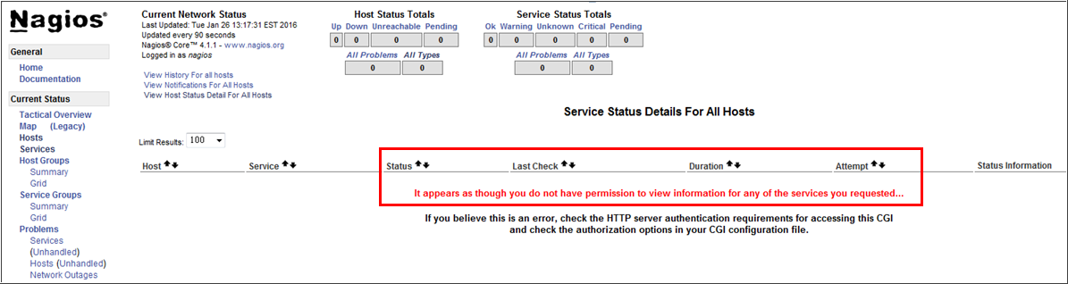

Possible Causes
The value of use_authentication in the /usr/local/nagios/etc/cgi.cfg file isset to 1.
Operation Procedure
            - Change the value of use_authentication.
- Open the /usr/local/nagios/etc/cgi.cfg file.
- Locate the use_authentication file.
- Change the value of use_authentication to 0.
            - Run the following command to restart the Nagios service:
            - service nagios restart
The detailed information about the host service status is displayed on the Nagios home page, as shown in Figure 1-1.
              - Detailed information about the host service status

----End

What Should I Do If SNMPv3 Alarms Cannot Be Reported?
Symptom
After an active/standby switchover between servers that use SNMP V3, alarms cannot be reported.
Blade servers do not support SNMP V3 alarm reporting.
Possible Causes
- After an active/standby switchover, server power-on/off, or server restart, the server engine ID changes.
- The event code and trap version reported by the server are inconsistent with the configuration.
The alarm on the server side must be in event code mode.
- The trap IP address is not registered on the server or the port is not 10061.
Operation Procedure
            - Check whether the IP address of the server is the same as the IP address in the configuration file of the Nagios plugin.
- Yes: Go to Step 4.
- No: Change the IP address in the configuration file of the Nagios plugin to the IP address of the server.
            - Check whether the server is powered on.
- Yes: Go to Step 4.
- If no, power on the server.
            - Check whether the alarm reporting function of the server is normal.
- Yes: Go to Step 4.
- No: Set the trap IP address reporting mode to event code, manually register the trap IP address, change the port number to 10061, and set the separator to comma (,).
            - Run the following command to query the alarm process ID:
ps -ef | grep trapd.py
            - Run the following command to stop the alarm process:
Kill -9 Alarm process ID
----End

